PRESS RELEASE
21 MAY 2018
Launch of a new public-private partnership to improve clinical trial infrastructure to facilitate the development of new drugs for children in Europe

The members of the “conect4children” (c4c) initiative today announced the start of a large collaborative paediatric network that will facilitate the development of new drugs and other therapies for the entire paediatric population in Europe. The conect4children (collaborative network for European clinical trials for children, (c4c) consortium aims to enhance the competitiveness of Europe as a critical region for developing medicines for children by using existing expertise, patient access and developing common processes to be applied to disease natural history studies, registries, studies of new therapies and comparisons of existing therapies.
The consortium is a novel collaboration between academic and private sectors that includes 33 academic and 10 industry partners from 20 European countries, more than 50 third parties and around 500 affiliated partners.
The six-year project, comprised of a multidisciplinary public-private consortium, brings together key stakeholders across academia and industry. It is a pioneering opportunity to build capacity for the management of multinational paediatric clinical trials across Europe whilst ensuring the voices of children, young people and their families are heard. Strong links with regulators will be established.
There are many scientific and operational challenges faced by both pharmaceutical companies and academia when running paediatric clinical trials. According to Prof. Carlo Giaquinto of Fondazione PENTA Onlus and University of Padova, who coordinates the project, “c4c will address critical problems with the design, implementation and operational conduct of paediatric clinical trials, such as fragmented and redundant efforts between sponsors, sites and countries; the paucity of patients available for study in many paediatric indications and the need for multiple capable sites and expertise to make trials successful.”
This project aims to generate a sustainable infrastructure that optimises the delivery of clinical trials in children through:
- a single point of contact for all sponsors, sites and investigators
- efficient implementation of trials adopting consistent approaches, aligned quality standards and coordination of sites at national and international level
- collaboration with specialist and national networks
- high quality input to study design and preparation through rigorous strategic and operational feasibility assessment
- the promotion of innovative trial design and quantitative science methods
- an education and training platform to shape the future leaders of paediatric drug development
- the development of sustainable support for all these activities
One of the key goals of the project is to support the use of innovative trial designs and new quantitative methods to foster development of new innovative medicines and to support development in rare paediatric diseases and high medical need area
“Children must have access to innovative medical therapies that have been developed with the same degree of urgency and rigor as those for adults,” said Joanne Waldstreicher, MD, Chief Medical Officer, Johnson & Johnson. “With conect4children in Europe joining in this effort, complementing work under way with I-ACT for Children in the United States, we will be able to accelerate the availability of high quality scientific data that can improve the safe and effective use of therapies in children."
“Clinical trials with medicinal products for paediatric use are one of the most sensitive areas in science – both from a medical and an ethical perspective”, said Dr. Michael Devoy, Chief Medical Officer of Bayer. “Improving the clinical trial infrastructure is an import step in enabling children to take part in medical progress”.
Dr. Mark Turner, Co-coordinator of the project, University of Liverpool, stated: “This network will have a significant impact on how we develop much-needed innovative and improved medicines for babies, children and young people. A number of collaborations built up over the past decade will contribute to this pan-European research network. The University of Liverpool is proud to be collaborating with institutions and research networks across Europe”.
Martin Schrappe (SIOP Europe President) stated: “The paediatric haematology and oncology community in Europe has made important strides to increase the rate and quality of cure for children and adolescents with cancer. Nevertheless, important needs remain and can only be addressed with further international cooperation and public-private partnership. There is a strong need for innovation and improvements to be made for the paediatric cancer sector”.
With a budget of about 140 Millions of Euros (IMI2 support of 67 Millions of Euros and industry partners’ in-kind contribution of 73 Millions of Euros), c4c is one of the biggest initiatives funded by the Innovative Medicines Initiative 2 Joint Undertaking (IMI2 JU) under grant agreement n º 777389. The Innovative Medicines Initiative 2 Joint Undertaking is Europe’s biggest Public Private Partnership and is funded jointly by the European Union´s Horizon 2020 research and innovation programme and the European pharmaceutical industry (represented by EFPIA, the European Federation of Pharmaceutical Industries and Associations).
- More info on IMI: www.imi.europa.eu
- Follow IMI_JU on Twitter: @IMI_JU
The parties involved
The project is coordinated and led by: Fondazione PENTA – for the treatment and care of children with HIV – ONLUS, The University of Liverpool, Janssen Pharmaceutica NV, Bayer AG.
Other partners are: Ospedale Pediatrico Bambino Gesù; EURORDIS – European Organisation for Rare Diseases Association; European Cystic Fibrosis Society; Stichting Katholieke Universiteit; Swiss Clinical Trial Organisation Verein; Associação para Investigação e Desenvolvimento da Faculdade de Medicina; Istituto Giannina Gaslini; University College London; SIOP Europe ASBL; Tartu Ulikool; Okids GMBH; University of Newcastle upon Tyne; Universiteit Gent; Universitaetsklinikum Heidelberg; Aristotelio Panepistimio Thessalonikis; Instytut Pomnik Centrum Zdrowia Dziecka; Helse Bergen HF*Haukeland University Hospital; ECNP Research & Scholarship Foundation; Robert Bosch Gesellschaft fur Medizinische Forschung MBH; University College Cork– National University of Ireland, Cork; Karolinska Institutet; Fundacio Sant Joan de Deu; Servizo Galego de Saude; Gyermekgyógyászati Klinikai Vizsgálói Hálózat; Fondazione per la Ricerca Farmacologica Gianni Benzi Onlus; ECRIN European Clinical Research Infrastructure Network; The Hospital District of Helsinki and Uusimaa; Institut National de la Sante et de la Recherche Medicale; HSK DR Horst Schmidt Kliniken Wiesbaden Gmbh; ARSENAL.IT-Centro Veneto Ricerca e Innovazione per la Sanità Digitale; Univerzita Karlova; Sanofi-Aventis Recherche & Développement; Eli Lilly and Company Limited; UCB Biopharma SPRL; Novartis Pharma AG; Institut de Recherches Internationales Servier; GlaxoSmithKline Research and Development LTD.; Pfizer Limited; F. Hoffmann – La Roche AG

The full list of organisations involved in the project can also be found at the c4c webpage www.conect4children.org

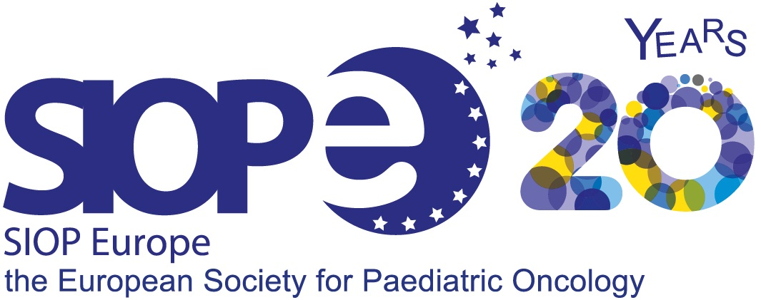
The European Society for Paediatric Oncology (SIOP Europe or SIOPE) is the only pan-European organisation representing all professionals working in the field of childhood cancers. With more than 1,730 members across 35 countries, SIOP Europe is leading the way to ensure the best possible care and outcomes for all children and adolescents with cancer in Europe. The SIOPE Strategic Plan ‘A European Cancer Plan for Children and Adolescents’ includes specific objectives and implementation platforms to achieve this mission. Learn more: www.siope.eu – office@siope.eu

– END –

Project Office/General Enquires: Email us. communication@conect4children.org
Disclaimer
This communication reflects the views of the c4c Consortium and neither IMI nor the European Union and EFPIA are liable for any use that may be made of the information contained herein

H2020-JTI-IMI2-2016-10. Proposal: 777389

