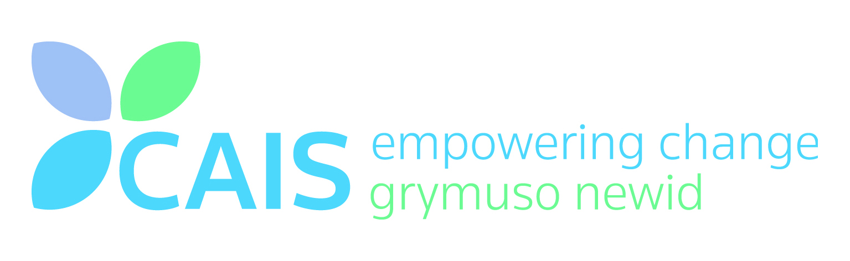
Job Description
Job Title | Young Persons’ Peer Mentor (16-24 year olds)
Department | Cyfle Cymru Out of Work Service
Base Location | Llandrindod Wells
Hours of Working | 15 hours
Salary | £18.115 per annum pro rata (£7,245.99)
Reports to | Lead Peer Mentor
Line Management Responsibility | Volunteer Peer Mentors

Job Purpose:
- To mentor Young People aged 16-24 across Powys who have been affected by substance misuse and/or mental health towards training and employment opportunities.
- Provide support and supervision to Volunteer Peer Mentors
- Work alongside the Volunteer Peer Mentors in delivering services and outcomes for the scheme
- To support the Lead Peer Mentor in raising awareness of the service
- To ensure project outcomes are delivered on target

Main Duties and Responsibilities:
- Source potential participants through referral routes.
- To ensure all project outcomes are delivered on target
- Provide support and guidance to all participants being referred onto the project.
- Assess candidates for suitability for further training and make appropriate referrals
- Source training and employment opportunities for a caseload of participants with the support of Cyfle Cymru Employment Specialists
- Work with the Volunteer Peer Mentors in bringing training and employment opportunities for participants to a positive outcome. This will include goal setting, CV writing, support with job applications, attendance at interviews and on-going placements
- Utilise any other tools and techniques such as brief interventions and Adult Directions in assisting participants achieve their goals and objectives for the Peer Mentoring Scheme.
- Provide ongoing support services to participants leaving the project
- Record all activities in compliance with both organisational and European Social Fund regulations. This would include client registration forms, timesheets and any other outcome monitoring required of the Scheme.
- To work alongside mental health peer mentors and employment specialists as well as service partners.

Client Work:
- To communicate skilfully and sensitively highly complex and sensitive information, taking into account sensory and cultural barriers to communication.
- To refer clients to other services within the partnership, and other external agencies as appropriate.
- To undertake and manage own peer mentor, volunteer and participant caseload.
- To be accountable for own decisions and actions in consultation with supervision.
- To undertake clinical administrative tasks and reports relating to mentoring project when necessary.

Policy and service development:

- To adhere to agreed Health and Safety and Security procedures/policies.
- To identify and contribute towards any aspects of the peer mentoring service where improvement can be made and to advise service and managers accordingly.
- To assist with the delivery of peer mentoring training if required.

Professional:
- To participate in the continuous learning, development and appraisal process.
- To operate within and observe partnership policies and procedures as amended and updated.
- To make regular use of supervision.
- To be responsible for working within own level of competence.
- To undertake internal and external training as appropriate, and as required as part of Continuous Professional Development.
- To develop and maintain professional working relationships with external agencies.

This Job Description provides a framework in which duties may be carried out, however it may be necessary to make alterations and adjustments from time to time to meet the needs of the service.

Person Specification for Peer Mentor
 | Essential | Desirable | Method of Assessment
Qualifications: | Good standard of general secondary education- minimum level C in Maths and English. | - Relevant training and/or relevant qualifications in substance misuse and mental health  - Relevant training and/or qualification in youth work  - NVQ Level 3 Advice and Guidance or willingness to work towards  - BTEC Level 2 in Peer Mentoring
Experience: | - Experience of working with young people aged 16-24  - Personal experience of substance misuse issues and/or mental health conditions  - Experience of working with individuals who have/had substance misuse issues and/or mental health issues | - Experience of multi-agency working
Skills: | - Ability to communicate with young people aged 16-24, preferably those with substance issues and/or mental health conditions  - Ability to initiate and maintain effective communication and working relationships with a relevant range of people and agencies  - An ability to work in partnership with other practitioners to deliver effective interventions and support for young people aged 16-24 with substance and/or mental health issues  - Competence with basic IT including MS word and MS Outlook  - Full driving licence and full access to a vehicle  - Competence with data entry and in house database systems | - The ability to communicate in Welsh and English  - An understanding of other key professionals, and how to contact them for consultation or referral
Knowledge: | - Knowledge of legislation relating to 16-24 year olds  - Awareness and understanding of current child protection and safeguarding legislation  - Understanding of Confidentiality and the implications surrounding it whilst working with young people aged 16-24 with substance and/or mental health issues | - Knowledge of safe working practice appropriate to the work  - Knowledge of local treatment services for substance misusing young people, what they offer and how to contact them
Personal Qualities: | - Willingness to adhere to CAIS policies relating to safeguarding and child protection  - Willingness to undertake further training as required  - Enjoy working with other people and have an enthusiastic passion for helping others achieve their goals  - Enthusiasm for working with young people aged 16-24  - Commitment to contributing in all project areas  - To be proactive and use own initiative  - Proven flexibility to meet organisational, project and client needs | - Proven good track record in previous employment relating to attendance
Other Relevant Requirements: | Readiness to undergo an enhanced DBS check (Children and Adults barred list)

